LEGENDARY DANCE LABEL
BIG BEAT RECORDS
CELEBRATES ANNIVERSARY WITH
“5 YEARS OF BIG BEAT”
COMPILATION OUT TODAY!

+ BIG BEAT/ATLANTIC AWARDED TOP HONOR AS BILLBOARD’S LEADING DANCE/ELECTRONIC LABEL 2015!

LISTEN/POST:
iTunes: http://smarturl.it/BigBeat5Year
Spotify: http://smarturl.it/S_BigBeat5Year
Beatport: http://smarturl.it/B_BigBeat5Year
Google Play: http://smarturl.it/GP_BigBeat5Year
Soundcloud: https://soundcloud.com/wearebigbeat/sets/big-beat-5th-anniversary

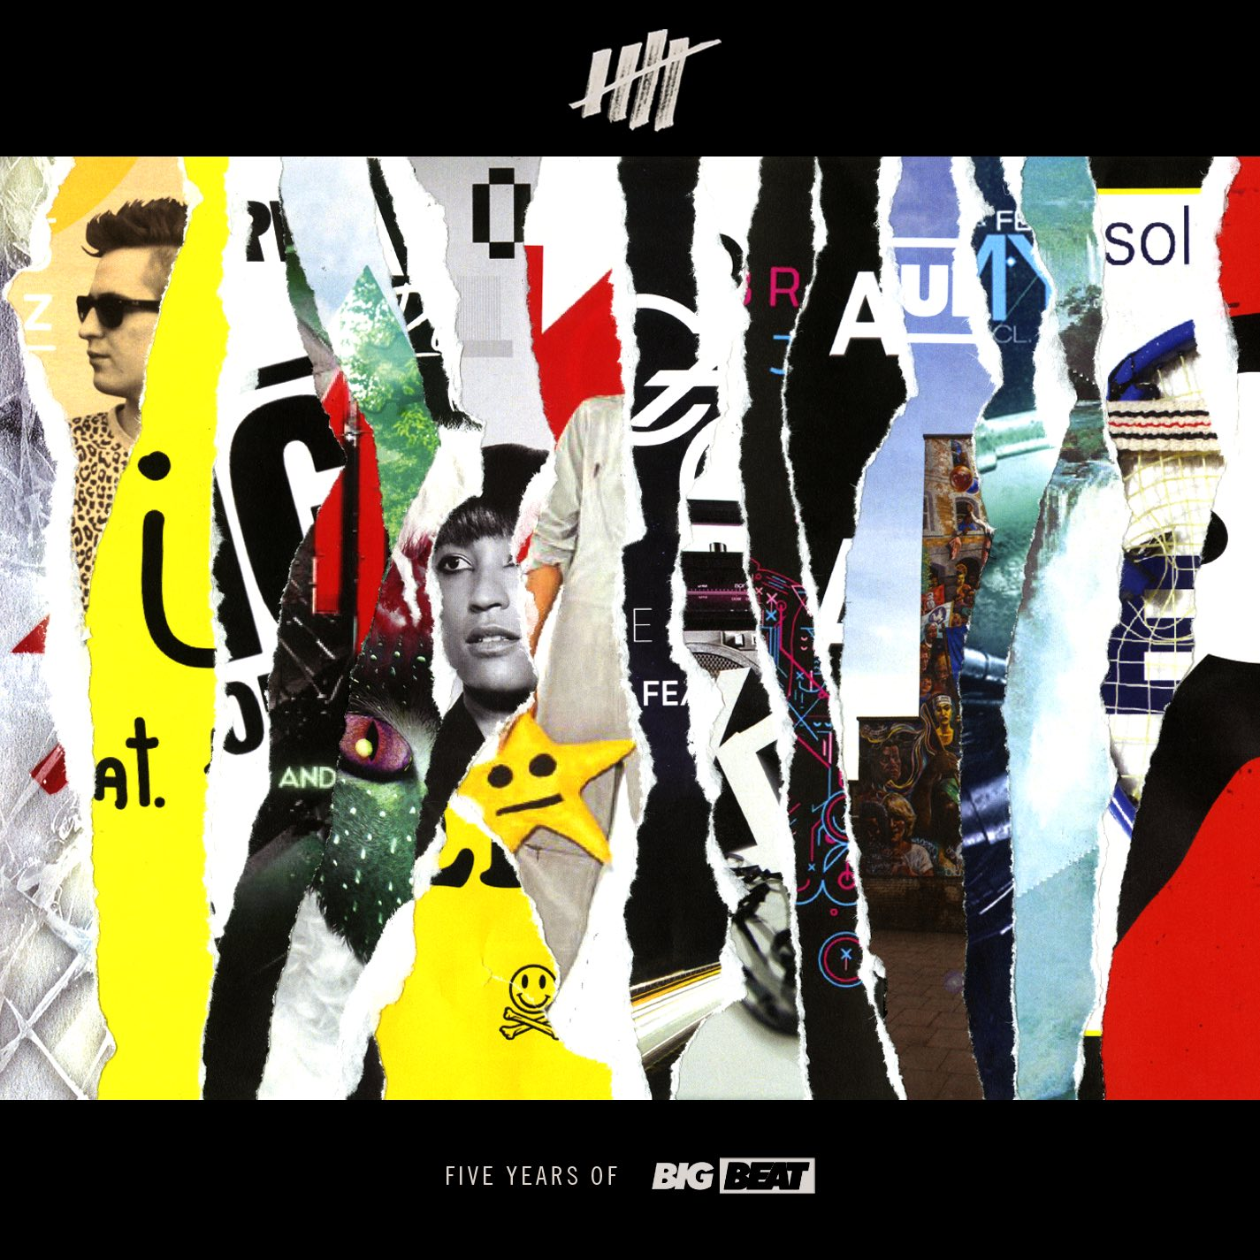

Rarely does a record label come along that clearly defines a sound, much less a generation, but Big Beat Records has done that and more, and is ready to celebrate their fifth anniversary in style. The label, which has played home to electronic stars as Skrillex, Icona Pop, Chromeo, Galantis and many, many more, releases a new compilation -- “5 Years of Big Beat” – out today (January 15th) to celebrate the milestone.

The compilation features 21 of their stand-out singles from the past five years, including cuts from Skrillex, Fatboy Slim, Duck Sauce, Knife Party, Rudimental, Jack Ü, Martin Solveig, Porter Robinson, and many more. “5 Years of Big Beat” will also feature four brand-new exclusive remixes from young rising producers that are bringing their fresh takes to indelible Big Beat classics; including a bouncy take on Cash Cash’s “Take Me Home” from Tarro, Maxx Live’s subdued remix of Icona Pop’s eponymous single “I Love It” ft. Charli XCX, DEVI’s rework of Rudimental’s “Feel The Love,” and Speaker of the House’s whimsical remix of Galantis’ smash hit “Runaway (U & I).”

On top of the 5th anniversary compilation, 2015 celebrated a big year for Big Beat/Atlantic Records. The label reigned with a #1 Single placement across 21 weeks, including smash tracks from David Guetta, Robin Schulz, as well as Skrillex & Diplo’s Jack Ü - the most of any electronic label, garnering top honors as Billboard’s Top Dance/Electronic Label of 2015!

Big Beat is home to such landscape-shifting artists as David Guetta, Skrillex, Clean Bandit, Robin Schulz, Galantis, Knife Party, Cash Cash, Rudimental, Chromeo, Martin Solveig, and Matoma. The label was founded in 1987 by then 21-year-old New York DJ and current Chairman & CEO of Atlantic Records, Craig Kallman, who started Big Beat in his bedroom.
Having become a major presence in the Dance and Hip-Hop underground, Big Beat was acquired by Atlantic Records in 1991 where it continued to flourish, releasing music from Lil Kim, Twista, Junior Mafia, Quad City DJs, Robin S., and more. The influential imprint was re-launched by Atlantic in 2010, and immediately re-established itself as the leading edge & preeminent force of today’s Dance/Electronic scene. Now home to multiple Grammy Award-winning and platinum-selling artists, Big Beat is a global brand representing the best of today’s Dance/Electronic artists.

“5 YEARS OF BIG BEAT” TRACKLIST

1 Skrillex & The Doors - Breaking a Sweat (Zedd Remix)
2 Martin Solveig & Dragonette - Hello
3 Duck Sauce - Big Bad Wolf
4 Knife Party – Internet Friends
5 Porter Robinson - Language
6 Ivan Gough & Feenixpawl - In My Mind (feat. Georgi Kay) (Axwell Mix)
7 Icona Pop - I Love It (feat. Charli XCX)
8 Breach - Jack
9 Cash Cash - Take Me Home (feat. Bebe Rexha)
10 Clean Bandit - Rather Be (feat. Jess Gynne)
11 Lilywood & The Prick & Robin Schulz - Prayer in C (Robin Schulz Remix)
12 Flux Pavilion - I Can’t Stop
13 Galantis - Runaway (U&I)
14 Skrillex & Diplo - Take Ü There (Zeds Dead Remix)
15 Cedric Gervais – Molly
16 Bingo Players – Cry (Just A Little)
17 Fatboy Slim - Eat Sleep Rave Repeat (Calvin Harris Remix)
18 Skrillex - Scary Monsters and Nice Sprites
19 Wynter Gordon - Dirty Talk (Laidback Luke Remix)
20 Rudimental - Feel The Love (feat. John Newman)
21 Cash Cash - Take Me Home (feat. Bebe Rexha) (Tarro's Big Beat 5th Anniversary Remix)
22 Icona Pop - I Love It (feat. Charli XCX) (Maxx Live's Big Beat 5th Anniversary Remix)
23 Rudimental - Feel The Love (feat. John Newman) (DEVI's Big Beat 5th Anniversary Remix)
24 Galantis - Runaway (U&I) (Speaker of the House's Big Beat 5th Anniversary Remix)
For more information: Web | Facebook | Twitter | Soundcloud | Spotify | Instagram

Press tools: press.wearebigbeat.com

Or please contact: Jordan Danielle Frazes via Big Beat Records: Jordan.Frazes@atlanticrecords.com

