ANTI UP RELEASE NEW SINGLE “SOMETHINGS ABOUT TO GO DOWN”

FOLLOWS “SHAKE” RELEASED IN MAY

LISTEN HERE

OUT TODAY VIA BIG BEAT RECORDS

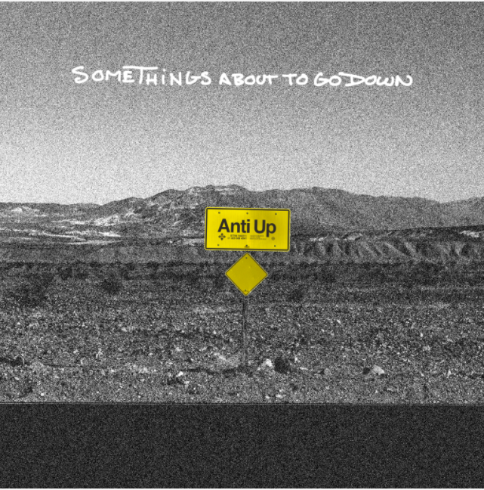
DOWNLOAD PRESS PHOTO HERE

Anti Up, a collaborative dance project from pioneering producer Chris Lorenzo and the GRAMMY-award nominated producer Chris Lake, release their 3rd club-ready single of 2021 today, “Somethings about to go down.” Listen HERE. “Somethings about to go down” follows May’s “Shake” and the duo’s highly anticipated return “Sensational,” released in March. Listen HERE.

Anti Up’s acid-laced, retro-fit stylings are a party - and everyone is on the guest list. A high-profile project with low-profile sensibilities, Anti Up has become a sounding board for dance music’s emerging voice. Bringing an ethos based in inclusivity and integrity, the international act has proven that true authenticity lies in playing by rules all their own. From the misfit kid who finds solace in new sounds, to the audiophiles in search of a high-octane sonic fix, the duo’s adrenaline pumping productions offer a reprieve from the worries and hassles of everyday life.

In 2018, the duo debuted with their own perfect take on cheese: “Pizza” -- a twisted, bubbly house track dropped via Ministry of Sound, which has stimulated after hours appetites the world over. Shortly after came their self-released Hey Pablo EP, a verified anthology of turn up tracks that put euphoric weekend feelings into musical terms, followed by a handful of noteworthy hits such as “Right Now”, another understated heater, not to mention a proper shout out to those moments when we feel so f*cking good.

CONNECT WITH ANTI UP
Instagram | Facebook | Twitter | Spotify

PRESS ASSETS: https://press.wearebigbeat.com/artists/anti-up/

FOR MORE INFORMATION:
Paige.Rosoff@atlanticrecords.com
Atlantic Records | Big Beat Records

###

