ANTI UP MAKES TRIUMPHANT RETURN WITH NEW SINGLE, “SENSATIONAL”

FIRST SINGLE FROM FORTHCOMING ALBUM

LISTEN HERE: https://antiup.lnk.to/Sensational

OUT TODAY VIA BIG BEAT RECORDS

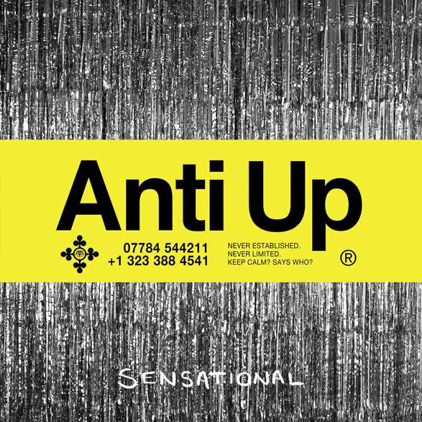
DL art here

It’s been a minute since we’ve heard from the dynamic production duo Anti Up, the collaborative house project from the pioneering house producer Chris Lorenzo and the GRAMMY-award nominated producer Chris Lake. After taking 2020 off from releasing music to truly hone their craft, the critically acclaimed duo is officially back with “Sensational”. Out today via Big Beat Records, “Sensational” is a feel-good anthem radiating with positivity that pays homage to the synthesizer-driven, arena-sized sound of the 80’s. Melding synthwave-leaning production with bass-forward house, “Sensational” seamlessly fuses Anti Up’s signature style into a cohesive dancefloor stunner - LISTEN HERE.

Anti Up’s acid-laced, retro-fit stylings are a party - and everyone is on the guest list. A high-profile project with low-profile sensibilities, Anti Up has become a sounding board for dance music’s emerging voice. Bringing an ethos based in inclusivity and integrity, the international act has proven that true authenticity lies in playing by rules all their own. From the misfit kid who finds solace in new sounds, to the audiophiles in search of a high-octane sonic fix, the duo’s adrenaline pumping productions offer a reprieve from the worries and hassles of everyday life.

In 2018, the duo debuted with their own perfect take on cheese: “Pizza” -- a twisted, bubbly house track dropped via Ministry of Sound, which has stimulated after hours appetites the world over. Shortly after came their self-released Hey Pablo EP, a verified anthology of turn up tracks that put euphoric weekend feelings into musical terms, followed by a handful of noteworthy hits such as “Right Now”, another understated heater, not to mention a proper shout out to those moments when we feel so f*cking good.

And even when we don’t, Anti Up is quick to infuse the room with positivity. After a year plagued by distress uncertainty, they return via Big Beat Records with “Sensational”, an effervescent, synth-scored track that cuts through the darkness that has become all too familiar. “Sensational” delivers a fresh kick of energy while paying homage to techniques made popular by vintage acts like Kraftwerk and New Order, among other pioneering electronic collectives.

In plain terms, Anti Up’s soundprint is a multi-sensory celebration of house music’s roots, and a gritty, offbeat glimpse into the genre’s beyond.

CONNECT WITH ANTI UP
Instagram | Facebook | Twitter | Spotify

PRESS ASSETS: https://press.wearebigbeat.com/artists/anti-up/

FOR MORE INFORMATION:
Paige Rosoff – Big Beat Records
Paige.Rosoff@atlanticrecords.com

