A7S UNVEILS EPIC VIDEO FOR NEW SINGLE ‘NIRVANA’

Watch the video HERE
All assets available here

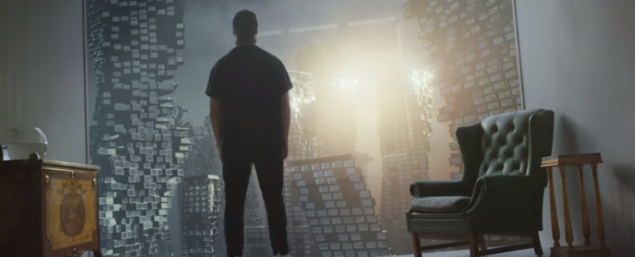

“A summer hit waiting to happen, and will be perfect for those pending nights out.” - CelebMix

“Nirvana bears all the hallmarks of another chart topping hit for the Swedish artist.” - Cultr

Global hitmaker, singer and producer A7S has unveiled an epic new video for his single ‘Nirvana’. Watch HERE! Directed by Rascal Post, the cinematic visual features A7S himself (real name Alexander Tidebrink) performing amidst breathtakingly stark, wintry and otherworldly landscapes, alongside a character played by Alma Helgesson.

Explaining the inspiration and themes behind the video, directors Gareth and Markus of Rascal Post say:

“When we first heard the song we instantly got inspired by the themes of nirvana and desire. Living in two parallel universes, A7S and the girl live in identical towering cities, they spend their time wandering vast alien landscapes scarred by ritualism and symbolism. Searching for their own Nirvana they learn to communicate with each other, tearing through time and space to spend one brief moment together.”

“As owners of an international visual effects company we really wanted to push the boundaries for how we use our unreal 3d technology. With artists all over the world from Sweden to New Zealand we were able to work around the clock to create epic scenes that belong on the big screen.”

A7S says:

"Sooo excited to show you guys this sick music video for Nirvana! Really loved making this one with @rascal.post and i'm so happy with the result! go check it peeps!"

Despite being responsible for some of the biggest global smash hits of the past two years, new single ‘Nirvana’ marks the first solo outing for A7S without the involvement of a featured performer or collaborating artist. An accomplished singer, songwriter and producer, A7S created the new single himself, which is currently topping over 5 million streams worldwide.

‘Nirvana’ follows previous tracks by A7S including the worldwide hit ‘Breaking Me’, the smash ‘Why Do You Lie To Me’ featuring Grammy-winning Atlanta rapper Lil Baby and ‘Your Love (9pm)’ with ATB - a reworking of the iconic original Ibiza house classic.

A7S is responsible for music which is widely recognisable across the globe. His humble beginnings growing up in the Swedish town of Ulricehamn saw him learn the craft of songwriting on the guitar and piano, a discipline he has retained all his life. Since those days he has written, sung and performed on many other artists’ tracks, soon achieving number ones across the globe including in Germany, China and his home country of Sweden. Fast forward to today and A7S has a total of over 2 billion streams of his music to date – including 350 million for ‘Your Love (9pm)’ - and a Billboard Music Awards nomination for Top Dance/Electronic Song with ‘Breaking Me’ with Topic.

CONNECT WITH A7S
Facebook | Twitter | Instagram | Spotify | Apple Music | Amazon | Tidal

FOR MORE INFORMATION
Paige.Rosoff@atlanticrecords.com
Atlantic Records | Big Beat Records

