100 gecs Shares New Video

Watch "Hand Crushed By A Mallet" (Remix) Feat. Fall Out Boy, Craig Owens and Nicole Dollanganger Here

New Album 1000 gecs & The Tree of Clues Out Now
Via Big Beat / Atlantic Records

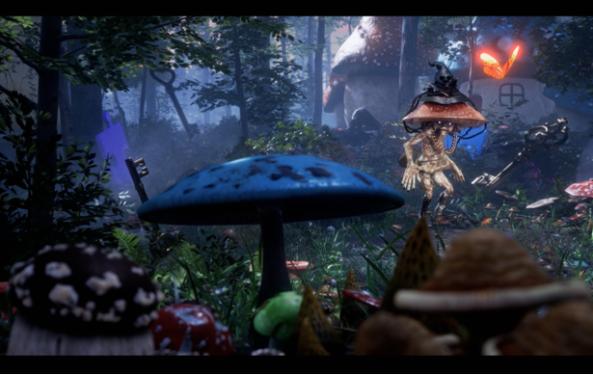video still

WATCH: "hand crushed by a mallet" feat. Fall Out Boy, Craig Owens, and Nicole Dollanganger
https://100gecs.lnk.to/newvideoPR

LISTEN: 1000 gecs & The Tree of Clues
https://100gecs.lnk.to/TreeofCluesPR

“utterly unhinged in the best way possible”
GQ

"[1000 gecs] was one of the most exciting things that happened in the whole decade. I really mean that"
Skrillex, in conversation with 100 gecs for PAPER Magazine

"It's fascinating and disorienting, and also some of the savviest pop music of the year"
The New York Times

“the truest, most authentic representations of the modern condition”
NPR

"a compelling case for the joys of having your brain permanently mangled by the internet"
Vulture

Today, 100 gecs are sharing a new video for their song "hand crushed by a mallet" (Remix) feat. Fallout Boy, Craig Owens, and Nicole Dollanganger. Directed by Dario Alva (Lady Gaga, Post Malone, Travis Scott) and written by Weston Allen (director of visuals for Dorian Electra), the animated visual is a whimsically bizarre take on a wild cat and mouse chase, a feral mushroom replacing the former. The visual is the third from their album 1000 gecs & The Tree of Clues following "stupid horse" (Remix) ft. GFOTY and Count Baldor and "gec 2 u" (Remix) ft. Dorian Electra.

Like it's predecessor, 1000 gecs, which was praised by Pitchfork as "one of the year's most fascinating, exhilarating experimental pop albums," 1000 gecs & The Tree of Clues pushes the boundaries of what music can sound like and breathes new life into one of the most exciting debuts in recent memory, with the standout single "money machine" taking over TikTok and YouTube again. Tree of Clues features a variety of collaborators from Fall Out Boy, Tommy Cash, and Hannah Diamond to Nicole Dollanger, Tony Velour, and more and includes new tracks "toothless" and "came to my show," their adult swim FishCenter live performances, and their previously-released singles "stupid horse" (Remix) ft. GFOTY and Count Baldor, "gec 2 u" (Remix) ft. Dorian Electra, "ringtone" (Remix) ft. Charli XCX, Rico Nasty, and Kero Kero Bonito, "745 Sticky (Injury Reserve Remix)" and "money machine" Remix by A. G. Cook. The album is also the first on their newly signed label Big Beat/Atlantic Records and took shape as the result of crowd-sourcing, garnering official remixes from friends and familiar names, as well as fans who received stems for the album via the band's Twitter.

1000 gecs & The Tree of Clues continues what is bound to be one of the gecs' most industrious years yet following their PAPER Pride cover, OFFICE Magazine cover and their virtual Minecraft festival experience, Square Garden, which Variety said "bore witness to eclectic DJ sets and a mouth-watering preview of the remix album" and featured performances from Charli XCX, Dorian Electra, Kero Kero Bonito and more, drew in 178,000 total viewers between Minecraft, Twitch and YouTube, and raised over $50,000 for Feeding America. All this after a whirlwind 2019 that saw the duo emerge as artists to watch behind their critically-acclaimed debut album 1000 gecs, released via Brady's own label, Dog Show records. The same year the gecs also embarked on a North American run with BROCKHAMPTON and slowthai, and somehow simultaneously took part in their own "Secret Tour" which saw the duo headline seven sold-out one-off shows, with dates in New York, Los Angeles, Chicago, Berkeley, Portland, Santa Ana, and St. Louis.

100 gecs is the groundbreaking pop duo of Dylan Brady and Laura Les, who planted their flag on the proverbial pop culture moon with their 2019 debut album 1000 gecs. The innovative project captured the hearts of fans and critics alike with The New York Times calling it, "Some of the savviest pop music of the year," and Interview Magazine suggesting that it is, "A blueprint for what pop music might sound like in the year 2050." In just a few months the band went from playing their first concert from inside the video game Minecraft to selling out shows across the country, proving that their rabid fanbase doesn't only exist in the far corners of the internet.

Watch "handcrushed by a mallet" (Remix) and listen to 1000 gecs & The Tree of Clues above, see track list below and stay tuned for more from 100 gecs coming soon.

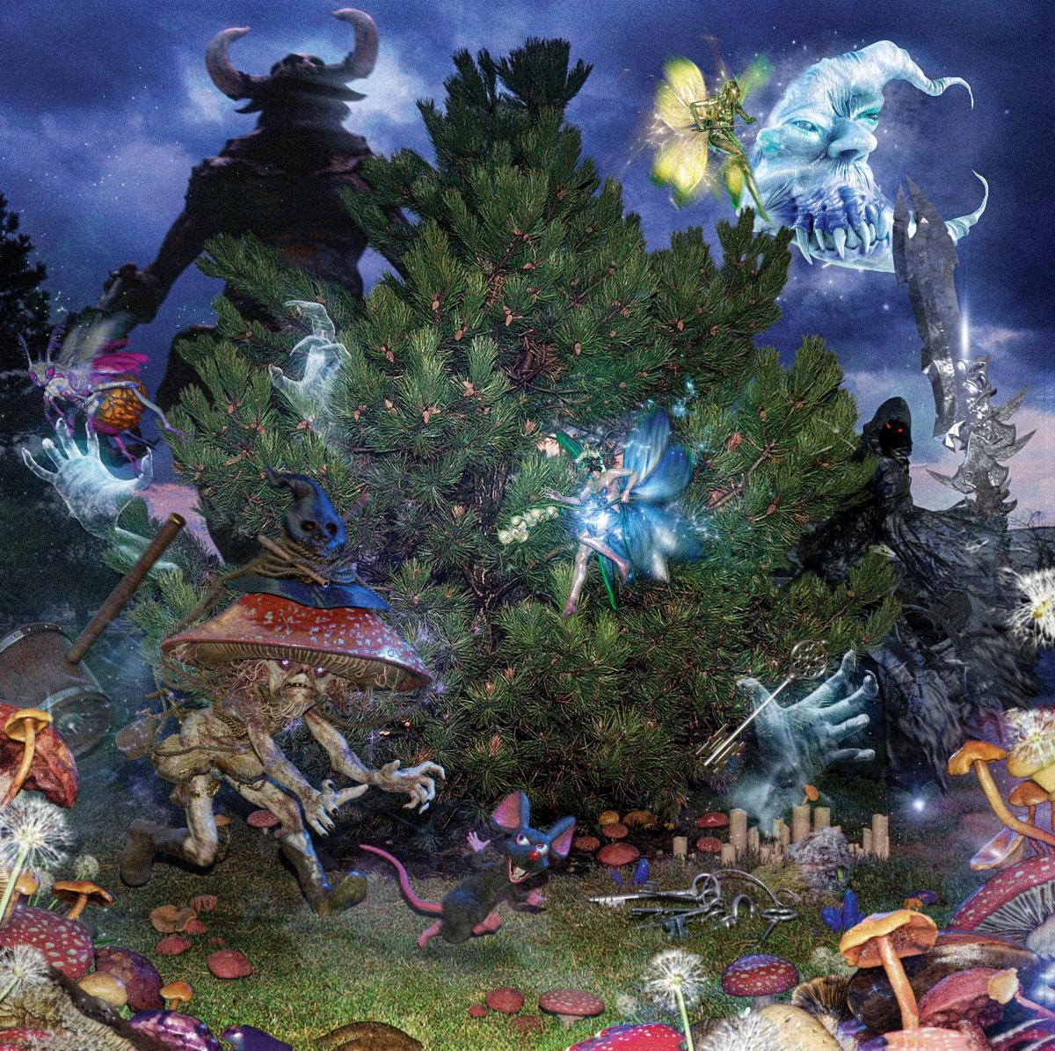
cover art

100 gecs
1000 gecs & The Tree of Clues
Big Beat / Atlantic Records
July 10, 2020

1. money machine (A. G. Cook Remix)
2. ringtone (Remix) feat. Charli XCX, Rico Nasty, Kero Kero Bonito
3. 745 sticky (Injury Reserve Remix)
4. gec 2 Ü (Danny L Harle Harlecore Remix)
5. hand crushed by a mallet (Remix) feat. Fallout Boy, Craig Owens, Nicole Dollanganger
6. 800db cloud (Ricco Harver Remix)
7. stupid horse (GFOTY and Count Baldor Remix)
8. ringtone (umru Remix)
9. xXXi_wud_nvrstøp_ÜXXx (Remix) feat. Tommy Cash & Hannah Diamond
10. 745 sticky (Black Dresses Remix)
11. gecgecgec (Remix) feat. Lil West and Tony Velour
12. xXXi_wud_nvrstøp_ÜXXx (99jakes Remix)
13. gec 2 Ü (Remix) feat. Dorian Electra
14. hand crushed by a mallet (nothankyou Remix)
15. came to my show (intro)
16. came to my show
17. toothless
18. small pipe (live at fishcenter)
19. 800db cloud (live at fishcenter)

100 gecs:
Twitter | Instagram | SoundCloud

Dylan Brady:
Twitter | Instagram | SoundCloud | YouTube

Laura Les:
Twitter | Instagram | SoundCloud

Dog Show Records:
Twitter | Instagram | Website

(Download hi-res assets HERE)

For 100 gecs inquiries please contact Paige.Rosoff@atlanticrecords.com

